Mongo DB NOSQL
Introduction :
MongoDB is an object-oriented, simple, dynamic and scalable NoSQL database. It is based on the NoSQL document storage model where the data objects are stored as separate and flexible JSON-like documents. The data objects are stored in a collection instead of columns and rows like a traditional relational database. This means that the fields can differ from one document to another and data structure can be changed over time.
The goal and purpose of MongoDB is to offer a data store that has high-performance, high-availability and horizontal scaling. MongoDB is easy to install and free to use.
Versions released prior to October 16, 2018, are published under the AGPL and its general distributions support Windows, Linux, Mac OS X, and Solaris.
MongoDB offers many advantages over traditional relational databases:
- Full cloud-based developer data platform
- Flexible document schemas
- Widely supported and code-native data access
- Change-friendly design
- Powerful querying and analytics
- Easy horizontal scale-out with sharding
- Simple installation
- Cost-effective
- Full technical support and documentation
- Higher performance due to the data models

SQL
Introduction :
SQL is a standard language for accessing and manipulating databases.
SQL stands for Structured Query Language that lets you access and manipulate databases, it became a standard of the American National Standards Institute (ANSI) in 1986, and of the International Organization for Standardization (ISO) in 1987
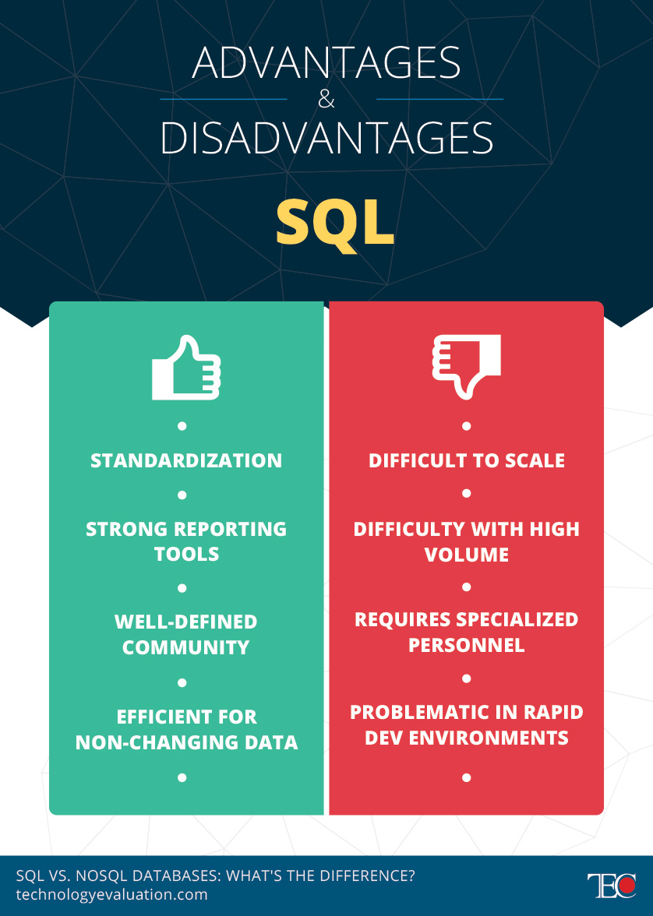

MongoDB VS SQL
 | SQL database | NoSQL database
Type | One database for everything | Various database models, such as document-oriented, graph, key-value, and column-oriented database
Data storage | Individual data (for example, “Book title”) is stored in rows in a table and assigned to specific attributes (for example, “Author,” “Year of publication,” and so on). The data sets are stored in separate tables and merged by the system during complex searches. | Instead of tables, NoSQL databases use either documents, key values, graphs or columns.
Schemas | Data type and structure are defined in advance. To store new information, the entire database must be customized (and taken offline). | Flexible. New data sets can be immediately added. Structured, semi-structured, and unstructured data can be stored together; no prior conversion is necessary.
Scaling | Vertical scaling. A single server must support the entire database system, causing a drop in performance when data volumes are high. | Horizontal scaling. Each administrator can add new commodity and cloud servers, and the NoSQL database automatically sends the data to all servers.
Development model | Open source (such as MySQL) or paid software (Oracle database) | Open source or paid software
ACID properties: Atomicity, Consistency, Isolation, Durability | SQL databases have all ACID properties. | ACID transactions are usually not supported in order to keep NoSQL databases flexible and horizontally scalable. Instead, the BASE model is used (Basically Available, Soft State, Eventually Consistent). This model prioritizes availability over consistency.
Performance | Uses indexes for large amounts of data. Queries, indexes, and structure must be optimized to improve the performance of SQL systems. | NoSQL databases are much more powerful because they use cloud servers and hardware clusters.
APIs | Queries for storing and retrieving data are submitted using Structured Query Language (SQL). | Data is stored and queried via object-based APIs.

